SOP for: (check one) Process Hazardous Chemical Hazard Class of Chemicals
Name of Procedure: Using the high vacuum pump to remove residual solvent
Applies to Lab (name): Chamberland Research Group | SCI Room #: 313
Prepared By: James Siegenthaler, Stephen Chamberland | Date: 8/30/12 | Revision: 10/7/14

Special Notifications:
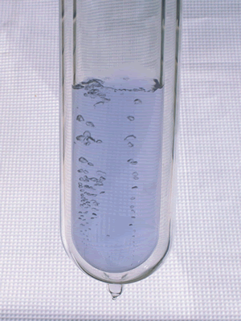
The high vacuum pump is an expensive and sophisticated piece of lab equipment. It may only be used to remove residual amounts (<<1 mL) of non-corrosive chemicals and solvents. Remove large amounts of solvent using the rotovap. After using the rotovap, enlist the house vacuum to remove visible amounts of solvent before using the high vacuum pump to eliminate trace solvent from your product.

Hazard Description:
Implosion of evacuated glassware can cause severe cuts and injury. Always check glassware for cracks and star cracks before placing it under vacuum. If glassware is cracked or has star cracks, do not place it under vacuum.
The pump has a strong motor and moving parts. Keep the belt guard attached at all times when operating the pump. Loose or hanging clothing, long hair or fingers can get caught in the belt or moving parts of the vacuum pump.
Liquid nitrogen can be used to protect the mechanical parts of the vacuum pump and the pump oil from chemicals and solvents. Work with liquid nitrogen cautiously to avoid burns to the skin. Also read the SOP “Using Liquid Nitrogen” before adding liquid nitrogen to the cold trap. Liquid Oxygen
If a blue liquid (liquid oxygen – picture at right, which is a strong oxidizer and will react with organic chemicals to produce an explosion hazard) is seen condensing in the trap, turn the pump off immediately, close the hood stash, and notify the PI and any coworkers in the vicinity of the hazard at once.
Never operate the high vacuum pump with liquid nitrogen as the trap coolant when the system is open to the atmosphere (as evidenced by a continuous audible gurgling sound). Continuous introduction of air into the pump will damage the pump. If a liquid nitrogen-cooled trap is being used, air (containing oxygen) can condense into the trap, which can cause an explosion.
Glass cuts on hands and fingers caused by breakage of stopcocks or changing tubing on the double manifold
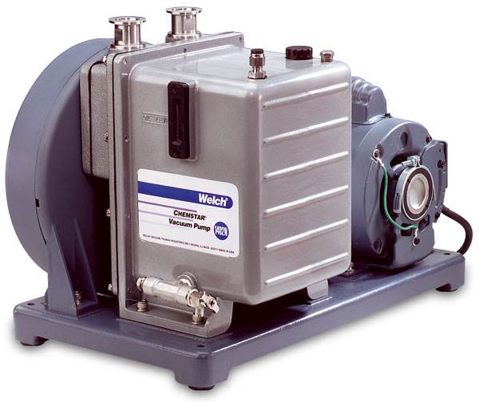
A
Figure 1. Our high vacuum pump

Protective Equipment:
- Lab coat
- Protective wrap-around safety goggles
- Thermally insulated gloves for handling liquid nitrogen
- Long pants
B
- Close-toed shoes
- Long hair tied back
- No dangling jewelry or clothing

Engineering Controls:
The vacuum pump is connected to a glass manifold (consult the SOP “Using the double manifold” for more information). Check for cracks or leaks before operating the high vacuum pump. The on/off (Figure 1, A) switch should be easily accessible. The oil level is visible from a gauge on the front (Figure 1, B) of the pump. Only operate the pump if the oil is at an optimal level and is clean. The color of clean oil ranges from colorless to slight yellow or light brown. Darker-colored oil indicates that the oil is dirty and must be changed to avoid damaging the pump. If an oil change is required, contact the PI for assistance and do not operate the pump. The power adapter should also be checked regularly for corrosion or damage. Failure to do so can cause severe damage to the machine based on the amount of current it draws.
Each bank on the double manifold (Figure 2) has three settings for the stopcock. When the blue dot is pointing up (12 o'clock), inert gases can come out of the manifold. When the stopcock is rotated 180 degrees and the blue dot is pointing down (6 o'clock), the hose will be connected to the vacuum pump. If the stopcock is horizontal, then the manifold is closed. The resting state of the manifold should be with the blue dot pointed to the right (3 o’clock). With the blue dot pointed to the right, the stopcock is being sucked into the manifold, which reduces leaks.

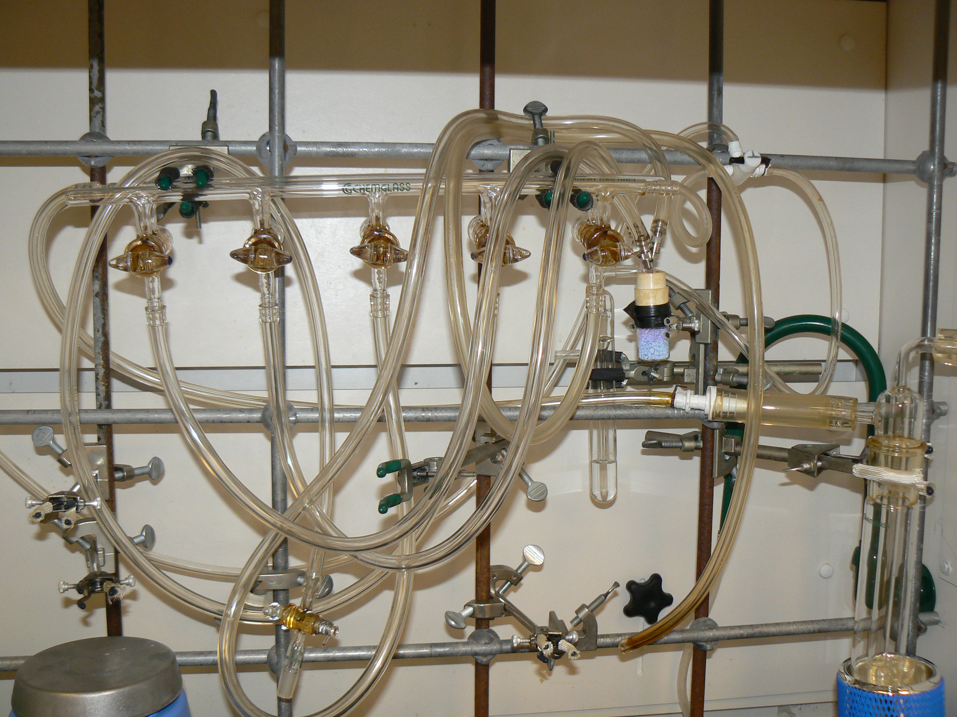Special Handling or Storage Requirements:
Figure 2. The double manifold
The pump should remain connected to the manifold when not in use, and rest on an oil pan or cardboard sheet for secondary containment to collect any leaking oil. If there are any problems or irregularities when using the pump, contact the PI immediately so that the problem can be diagnosed and fixed before it gets worse and damages the pump.

Spill Response Procedure:
If oil is spilled from the pump, clean with CH₂Cl₂ followed by hexanes to remove the spilled oil. Wear chemically resistant nitrile gloves when handling chemically contaminated oil and when cleaning up spilled oil with CH₂Cl₂ or hexanes. Leaking oil is not normal, and the PI should be notified to identify problems with the pump. If LN₂ or dry ice/isopropanol is spilled, clear the area and allow the coolants to evaporate. DO NOT USE if the machine is leaking oil.

Decontamination/Waste Disposal:
Cleaned oil and the solvent used to clean the oil should be collected and disposed of in the organic hazardous waste container.

Special Emergency Procedures:
If the pump fails to work properly, immediately turn it off and notify the PI.

Procedure may be performed after normal working hours (M-F, 8-5)? Yes No

Procedure may be left unattended? Yes No

Step by Step Procedure:

Read each step carefully before proceeding. Failure to do each step in the proper order can damage the pump, cause an explosion, or both.

Important: To begin, turn on the pump first, then cool the traps. When the pump will not be used again for a long period, lower the cold traps first, then turn off the pump.

- Assemble the cold traps and hold them together using the pinching metal clamps provided. Before turning on the pump, make sure that all stopcocks on the manifold are closed to the vacuum bank and that the hole in the stopcock points up.
- When the glassware connected to the pump is closed from the ambient environment, turn on the pump using the metal on/off switch (Figure 1, A). Initially, a gurgling sound may be heard that should be inaudible after ten to twenty seconds. If the gurgling sound persists, turn off the pump by switching off the metal on/off switch. A gurgling sound is indicative of a substantial leak that’s sucking air into the pump, which can overheat and damage the pump.
- After the pump is on, raise the dewar flasks so that they surround the bottom finger of each cold trap. Two cold traps must always be used. Each dewar flask should be sitting on a sturdy, adjustable lab jack that is on a sturdy, level surface. Clamp each dewar to the metal bars in the hood using a chain clamp.
- You must chill the traps before evacuating glassware containing reaction products. Do not chill the traps with liquid nitrogen. To cool the traps, slowly fill each dewar about halfway with isopropanol. Then, add dry ice pellets one at a time until the vigorous bubbling calms, then add pellets a few at a time. Continue to slowly add more dry ice pellets until the level of the slurry is visibly near the top of the dewar flask. Wrap a lab towel around the top of each dewar and the cold trap to insulate the system and slow evaporation of the solution. Dry ice/isopropanol is not sufficient to cool the trap unless a second dry ice/isopropanol trap is set up in series. We are using two traps in series.
- Once the cold traps are cold, connect the glassware that is to be evacuated to the manifold using a hose adapter with or without a stopcock. Apply a minimal amount of vacuum/stopcock grease to the top half of the ground-glass joint on the hose adapter to decrease leaks. If a fine, particulate solid or powder is being dried, use a glass-fritted hose adapter to prevent the solid from being sucked into the pump. Secure the flask using a sturdy metal three-pronged clamp to attach the flask at its neck to the metal bars in the hood. Alternatively, the flask can be rested in an appropriately sized cork ring that sits on a flat surface, preferably on the floor of the fume hood.
- Slowly turn the stopcock connected to the flask and open the flask to the vacuum. Initially, a gurgling sound may be heard (especially if a 100 mL flask or larger is being evacuated) that should be inaudible after ten to twenty seconds. If the gurgling sound persists, there is a leak, so turn the stopcock back to the initial position (blue dot at 3 o’clock)
- Close the hood sash and allow the pump to run until for the desired time, and check the solvent trap coolant often and replenish if necessary.
- When finished, it is imperative that the following steps be completed in the exact order stated. Turn the stopcock connected to the flask back to the initial position (blue dot at 3 o’clock). If backfilling with nitrogen gas is desired, make sure that the nitrogen gas is on and backfill slowly so that mineral oil from the bubbler is not drawn into the manifold. Steps 9 and 10 should be done quickly and in the exact order stated.
- Turn off the pump and then rotate the stopcock to open the manifold to the air.
- When the system is exposed to air, lower the dewars containing the cooling liquid to allow the cold traps to warm.
- The cooling liquid may remain in the dewar if the pump will be used again soon. Alternatively, pour the solution in the organic waste container once it has warmed to room temperature if the pump will not be used again for more than a few days.

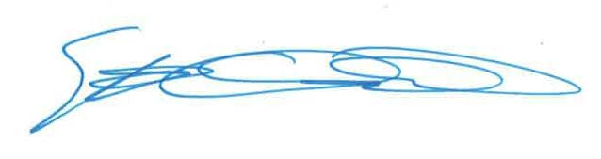
Approved By (PI) : Stephen Chamberland, Ph.D. Date: 10/7/14

PI Signature: ___________________________________________________ Date: ____10/7/14____

EH&S Signature: ________________________________________________ Date: ______________

