SOP for: (check one) Process Hazardous Chemical Hazard Class of Chemicals
Name of Procedure: Using the double manifold
Applies to Lab (name): Chamberland Research Group | SCI Room #: 313
Prepared By: Stephen Chamberland | Date: 9/19/12 | Revision: 9/19/12

Special Notifications:
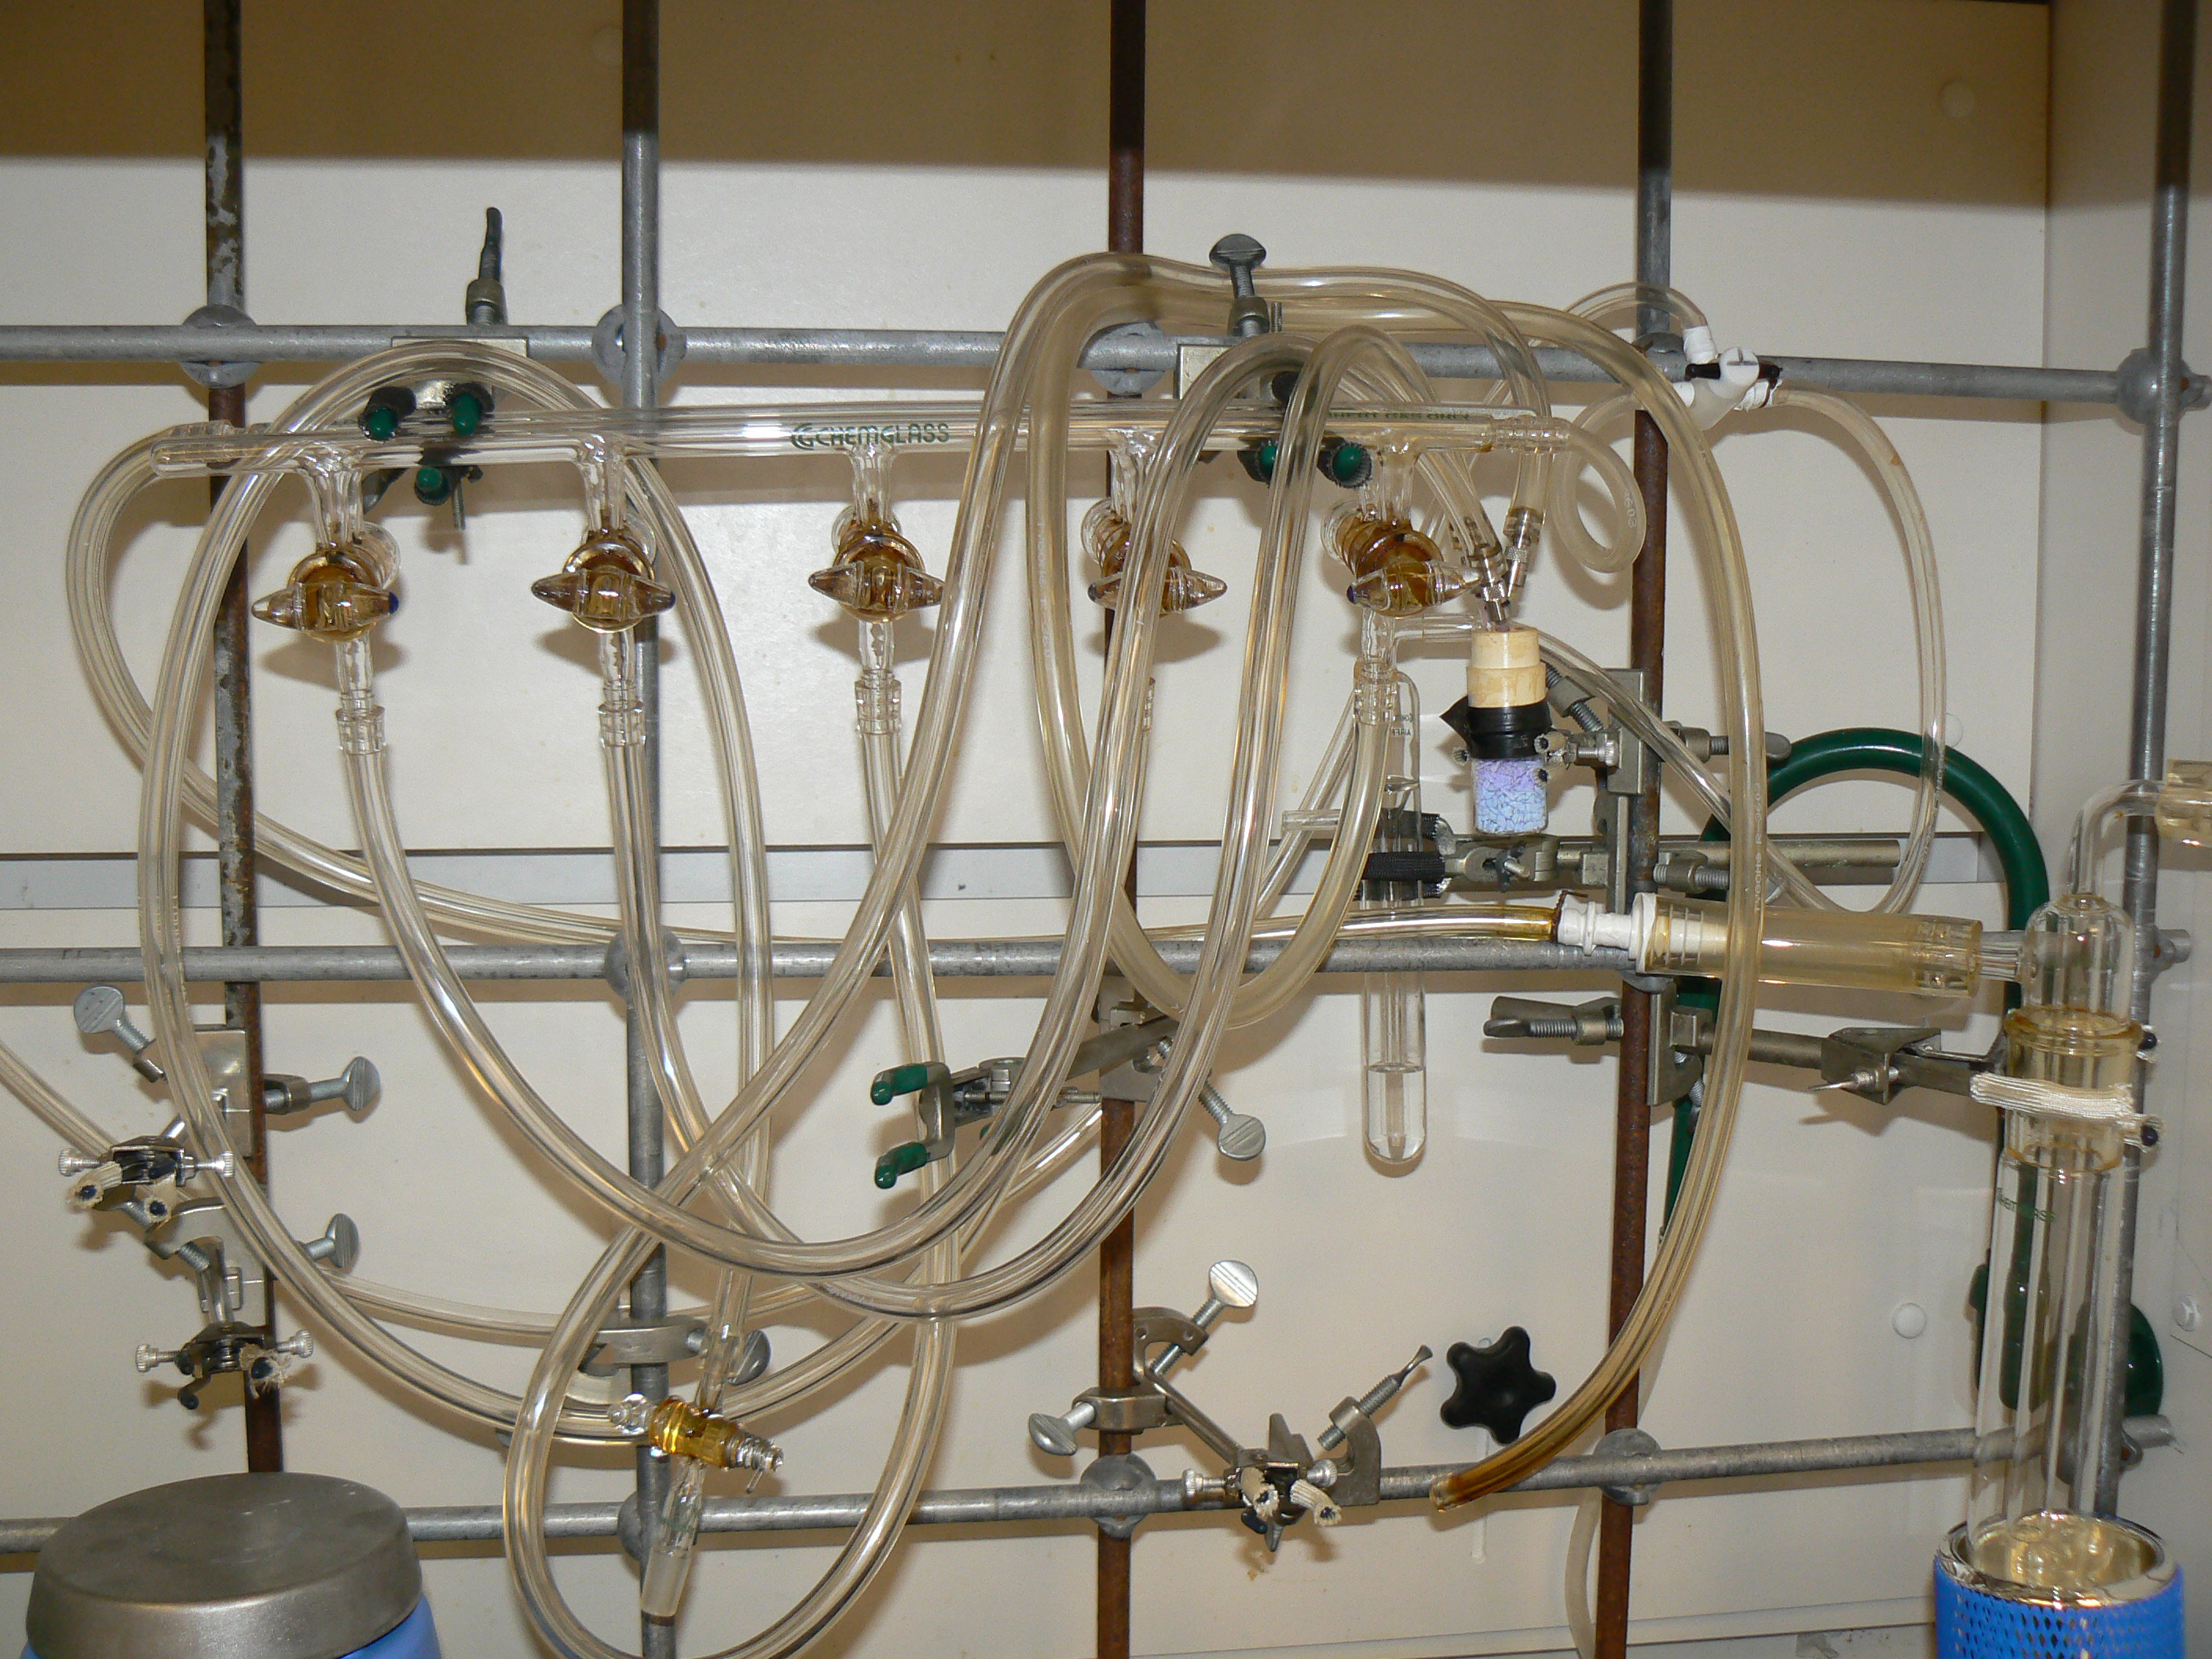Schlenk lines (inert gas/vacuum apparatus) are an apparatus useful for performing a variety of common laboratory techniques under air-free conditions. A well-maintained Schlenk line will allow you to do the following: flame dry glassware (only Dr. Chamberland can flame dry glassware), vacuum distillation, freeze-pump-thaw degassing, removal of residual solvent, vacuum transfer purification, and run a reaction under an inert or reagent gas (most common use). The apparatus consists of two long glass cylinders (lines) with valves on the bottom to connect glassware using flexible Tygon tubing, a vapor trap (glass cold finger with a Dewar to keep the refrigerant cold) to the right, a gas bubbler behind it, and may have a belt-drive vacuum pump connected to a liquid nitrogen vapor trap. It will always be connected to a gas drying unit and an inert gas (N₂ or Ar) cylinder.
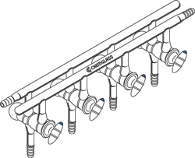

Figure 1. Schlenk Line, or inert gas/vacuum double manifold
Figure 2. Picture of one of our double manifolds
You will receive thorough training on inert gas/vacuum line technique by Prof. Chamberland and/or a trained group member before using the vacuum pump (see the SOP “Using the Vacuum Pump”). However, remember that many of the techniques involved can be confusing, and the consequences of making a mistake can be very dangerous as well as costly. Therefore, if you are ever in doubt about how to do something, please be sure to ask Prof. Chamberland or an experienced group member before proceeding.

Hazard Description:
Pressure can build up or decrease sharply and unexpectedly. Be aware of any action done to the manifold and the likely consequences. Pressurized glassware can explode or cause a stopcock or septum to pop, causing injury if the user is not behind the fume hood sash

Protective Equipment:
- Lab coat
- Protective wrap-around goggles
- Long pants
- Close-toed shoes
- Other precautions based on the chemicals used

Engineering Controls:
Use the double manifold in the fume hood only, with the sash lowered as much as possible.

Special Handling or Storage Requirements:
N/A

Spill Response Procedure:
N/A

Decontamination/Waste Disposal:
N/A

Special Emergency Procedures:
If pressure builds up unexpectedly, open up other stopcocks to vent the pressure and/or add exit needles through the septum in the reaction flask.

Procedure may be performed after normal working hours (M-F, 8-5)? Yes No

Procedure may be left unattended? Yes No

Step by Step Procedure:

For step-by-step procedures on vacuum distillation, freeze-pump-thaw degassing, removal of residual solvent, vacuum transfer purification, see the corresponding relevant SOPs.

To run a reaction under an inert or reagent gas (most common use), dry the reaction flask and stir bar in the oven overnight and/or have Dr. Chamberland flame dry the flask (only Dr. Chamberland can perform flame drying, when necessary). Take the flask with stir bar out of the oven and quickly cap it with a rubber septum, being sure to fold down the septum over the rim of the flask. Place the flask in a cork ring or clamp it to the metal bars in the hood using a sturdy metal three-prong clamp. Make sure the nitrogen gas is on, as evidenced by activity in the bubbler. Insert a needle (from one of the Tygon tubes coming from the manifold) through the septum and open the stopcock to the nitrogen gas. The flow of nitrogen should be about 3-5 bubbles per second when cooling a flask under inert atmosphere because negative pressure will result due to the cooling process. Remember that PV = nRT, so pressure and temperature are correlated. Insert an unobstructed pink 16-gauge disposable needle through the septum as well, and then immediately turn the three-way stopcock connected to the bubbler such that nitrogen is not flowing through the bubbler. CAUTION: If you don’t have the exit needle in the flask when you turn off flow to the bubbler, pressure can build up quickly causing part of the apparatus to pop out violently and break. Cool the flask under the flow of inert gas. When the flask has cooled sufficiently (usually to room temperature), remove the exit needle from the septum and then immediately turn the three-way stopcock to include the bubbler so that bubbling is visible. For normal reactions at or above room temperature, adjust the nitrogen pressure so that the bubbler is just barely bubbling (one bubble per minute). The flask is now set up for reaction under inert atmosphere.

Remember that if a reaction is run above room temperature that the nitrogen pressure will need to be increased slightly as the reaction cools to room temperature. If a reaction is run below room temperature, the pressure will need to be increased slightly as the reaction cools to the required temperature.

Use and Maintenance of the double manifold

Glass Stoppers: The access points to the nitrogen or vacuum lines should be closed whenever not in use or performing maintenance. The greased stopcocks are “vacuum backed” – they should have the colored side of the stopcock pointed to the right when not in use to utilize the vacuum line (if connected to vacuum) to “pull” the stopcock into the joint. Failure to have the proper resting state for the line might cause a stopcock to be forcibly ejected from the line, damaging the stopcock ($$) and/or the user. The Teflon stoppers and greased stopcocks should be removed and cleaned periodically to remove chemical residue that has built up. A base bath is usually used to clean the double manifold and all stopcocks. See the SOP “Preparing and using a base bath for cleaning glassware”, to learn how to clean the manifold with a base bath. You should do this as needed. Inert Gas Bubbler: You should be sure that your bubbler is filled with about one inch of mineral oil.

Keep the following in mind:
1) Nitrogen (or Argon) should be on only when needed. We pay for N₂, so shut off the nitrogen flow when you don’t need it.
2) You can use your bubbler to adjust the N₂ pressure by closing or opening the ridge-edged black disc furthest from the main gas tank valve (most common), or rarely, the spring-loaded Teflon screw (the big black plastic knob on the regulator, it is very sensitive). Standard bubblers can be adjusted in a similar way by placing a C-clamp on the Tygon tubing before the bubbler. When raising the pressure, remember that PV = nRT, and that the weakest point in your pressurized line is the one that will pop if the pressure gets too high. I’ve seen septa ejected from RBF’s (and they’re on pretty tight) because a N₂ needle was inserted at too high a pressure. The same can happen to ground glass joints or stopcocks. Over pressurized bottles are more likely to explode, sending glass and flaming reagent all over the place.
3) Use common sense and always think of the possible consequences before you manipulate any part of the inert gas line or vacuum on the manifold. Pressure can build up and fall quickly, so beware.
4) Maintenance of the gas line and manifold:

The tubing: If the tubing is clogged with visible solids or has yellowed significantly, replace it. Replacing the tubing is much cheaper than the lost time brought about by introducing contaminants from the tubing into your reaction or your purified product.

The glass manifold and stopcocks: Under normal circumstances, this should require minimal maintenance. Periodic cleaning with degreasing solvent (hexane or CH₂Cl₂), acetone, water, and then i-PrOH and/or a base bath is recommended. You should clean it as needed; for example, if you inadvertently pull a compound into the line (including HCl, a common mistake) or oil from your bubbler (this will happen if you’re not paying attention during evacuation/backfill cycles). If once-reliable but sensitive chemistry suddenly stops working, clean the manifold.

Approved By (PI) : Stephen Chamberland, Ph.D. Date: 9/19/12

PI Signature: ___________________________________________________ Date: ______________

EH&S Signature: ________________________________________________ Date: ______________

